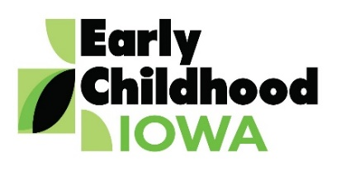**Kids First Communities Early Childhood Area**

**Serving Clarke, Decatur and Wayne Counties**

**Friday, March 7, 2025 • 12:00 PM Special Board Meeting –**

**Virtual Meeting Only**

**Zoom Meeting Information Below**

**Zoom Link:** https://us02web.zoom.us/j/83937272893?pwd=jW8LU5V6RReswWR9Uq1vayl0Z96ib0.1

**Call in information:** 1 312 626 6799 **Meeting ID:** 839 3727 2893 **Passcode:** 503468

**MEETING AGENDA**

|  |  |  |
| --- | --- | --- |
| **Call to order** |  | Information |
| **Declaration of quorum** |  | Information |
| **Introductions** |  | Information |
| **Public Comments** |  | Information |
| *Persons wishing to address the Board are requested to identify themselves and state the matter on which they wish to comment. The Board will appreciate your cooperation in keeping your comments brief. Please observe a three minute limit to communications.* | | |
| **Corrections to agenda-if needed** |  | Action Item |
|  |  |  |
| **Approval of agenda** |  | Action Item |
|  |  |  |
| **New Business:** |  |  |
| New ECI Districts – District 5 |  | Information |
| Merger of Boards |  | Action Item |
| RFP FY2026 |  | Action Item |
| New District Board Member Interest |  | Information |
|  |  |  |
| **Old Business:** |  |  |
|  |  |  |
|  |  |  |
| **Next Scheduled Meeting:** March 20, 2025 |  |  |
| Future Meetings: |  | Information |
| 5/15/2025, 6/19/2025 |  |  |
|  |  |  |
| **Adjournment** |  | Action Item |
|  |  |  |
|  |  |  |